Bharat Sanchar Nigam Limited
(A Govt. of India Enterprise)
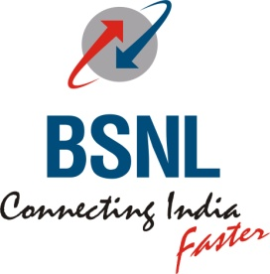 Office of the General Manager, (Sales & Marketing - Consumer Mobility)
Tamilnadu Circle, Chennai 600 006
[CSC SECTION]

To
Heads of all SSAs
NO. CSC/T114/RTMS/ 2011-12/25 Dt at Chennai 6 the 27/03/2012

Sub: RTMS Creation Procedure and Contact details-reg
*********
The RTMS Creation Procedure and Contact Details as received from EB Cell. Circle Office Chennai is furnished below for the use of RTMS Nodal officers;

PROCEDURE FOR CREATION OF RTMS CONNECTIONS AND CONTACT DETAILS
Open the site 10.32.32.216 Go to procedure . Go to RTMS creation procedure and connection to be created as per the details in the site.
OR double click below for RTMS Creation Procedure and RTMS Application Form
The CSC INCHARGES/Those who are dealing with RTMS may contact the following officers in case of any problem.
Contact details:
Sri L Krishnamurthi AGM EB , TN Circle 9444000048 – Coordinating Officer
Sri S Murugavel SDE EB , TN Circle - 9486101926- Coordinating Officer
Sri.Pagalavan JTO CHTD 9444000246 , Creation related clarification
Smt.Bhooma SDE 9444400101---LBA screen opening and updating related
Sri.Muralidharan SDE,9444979863 --- DO
Smt Roopa JTO,9445476672 ----- DO
Smt.Sreedevi JTO 9444005058 ---Tracksoft Existing acc deletion,wrong
activation related issues
Sri Appadurai AGM VAS 9444979616,
Sri.Balaji DGM VAS 9445022200
For deletion, mail is to be sent to traksoft.chennai @gmail.com
For LBA issues , mail to sent to lbachennai@yahoo.com

Sd/..…
G SWAMINATHAN
AGM (CSC)

